**From:** Soh, Ivy   
**Sent:** Wednesday, 17 January, 2018 8:42 AM  
**To:** Chan, Pei-Fong  
**Cc:** Tan, Yan Zhang; Ng, Crystal; Ng, Xiang Yue; Susan, Chong  
**Subject:** RE: Old WMS - IBM S&D

Hi Pei Fong,

Please create bill groups for the following:

1. Galaxy – ZG / OH / QD
2. Decom - DE

Appreciate your assistance. Thanks.

Are we able to run report with ‘selective’ business units meaning when I select ZG/ OH/ QD it will only run these 3 business instead of now it is running the whole of the 4 business unit.

ZG (Zero GST)

OH (On hold)

QD (quanta)

DE (decom)

**Changes:**

Classify Billing group to enable retrieve report by selected group.

## Codelkup:

List name = 'AMProdCat'

select * from CODELKUP where LISTNAME = 'AMProdCat'

Long = Billing Group

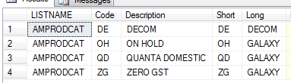

## Daily Receiving Report

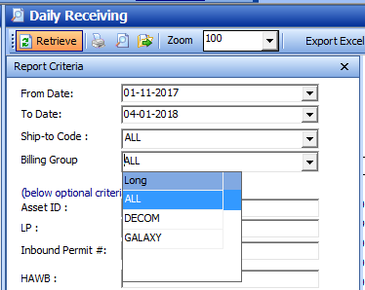

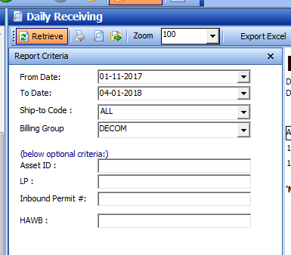

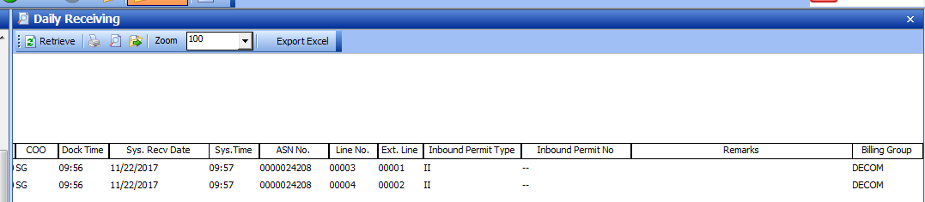

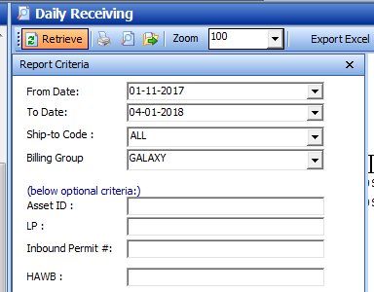

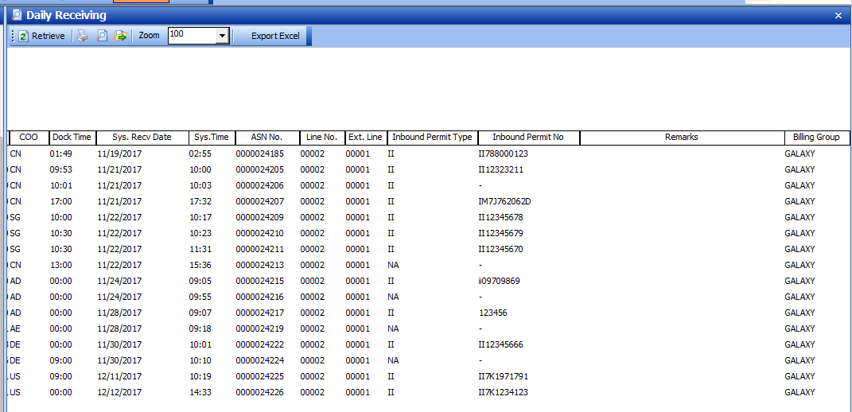

## Daily Outgoing Report

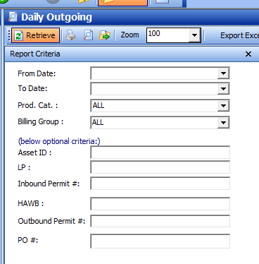

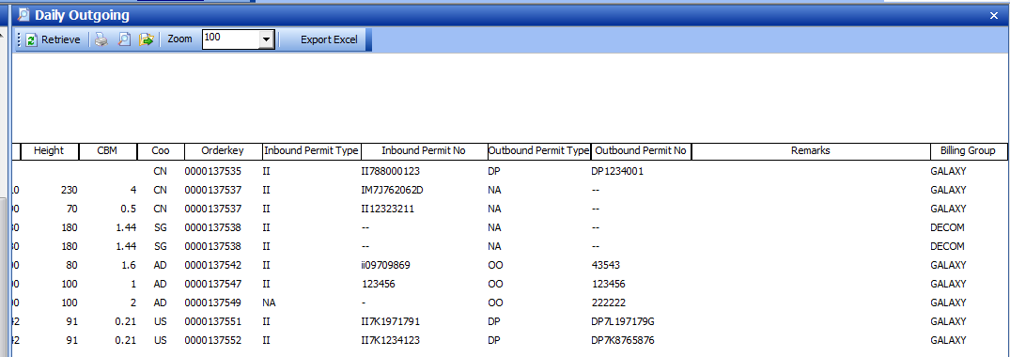

## Inventory Report

